**Case Study – MongoDB**

**Database:** Products

**Collection**: lists

1. **Find all the information about each products:**

* **{ } 🡪** It shows all the documents which contains the product information

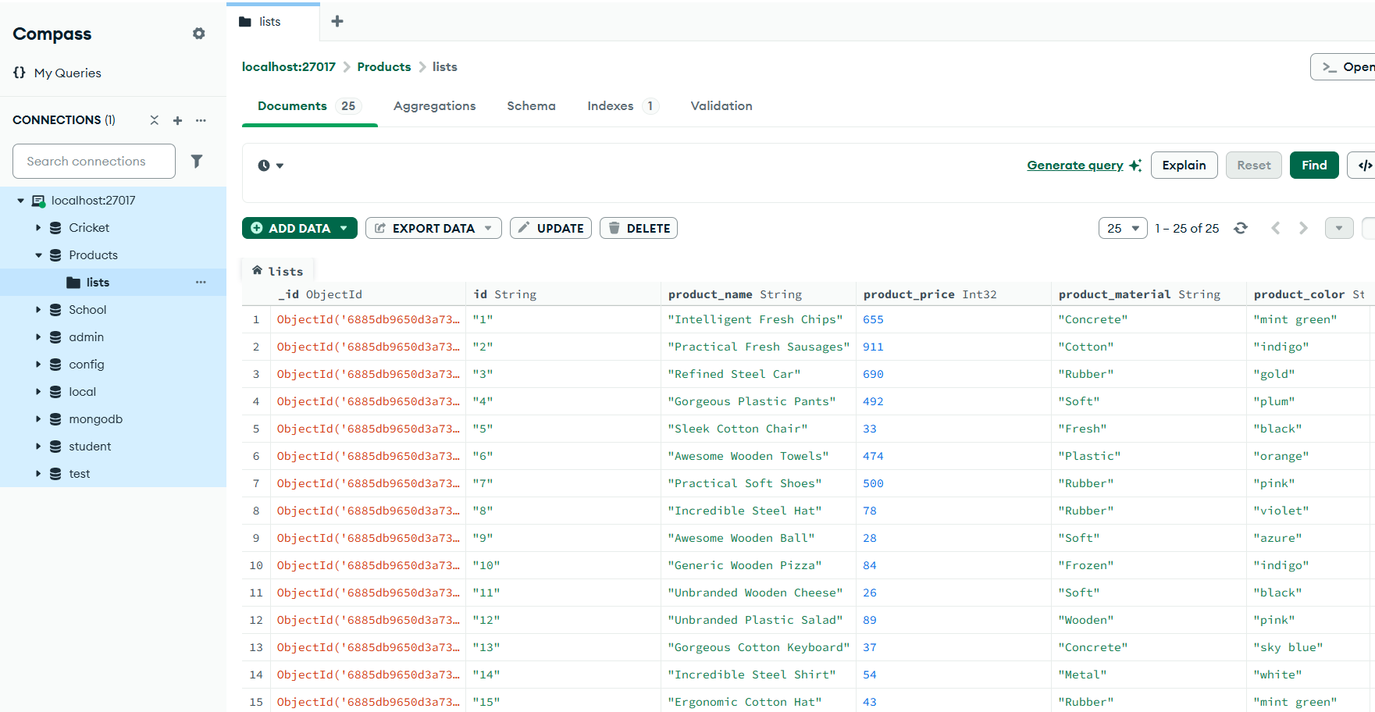

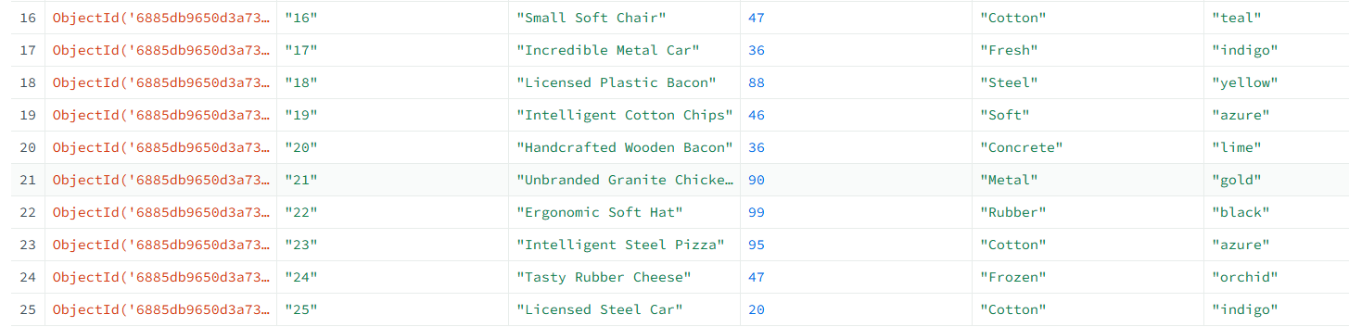

1. **Find the product price which are between 400 to 800**

**{ "product_price": { "$gte": 400, "$lte": 800 } }**

* It shows the products where product_price is greater than/equal to 400 and less than /equal to 800.

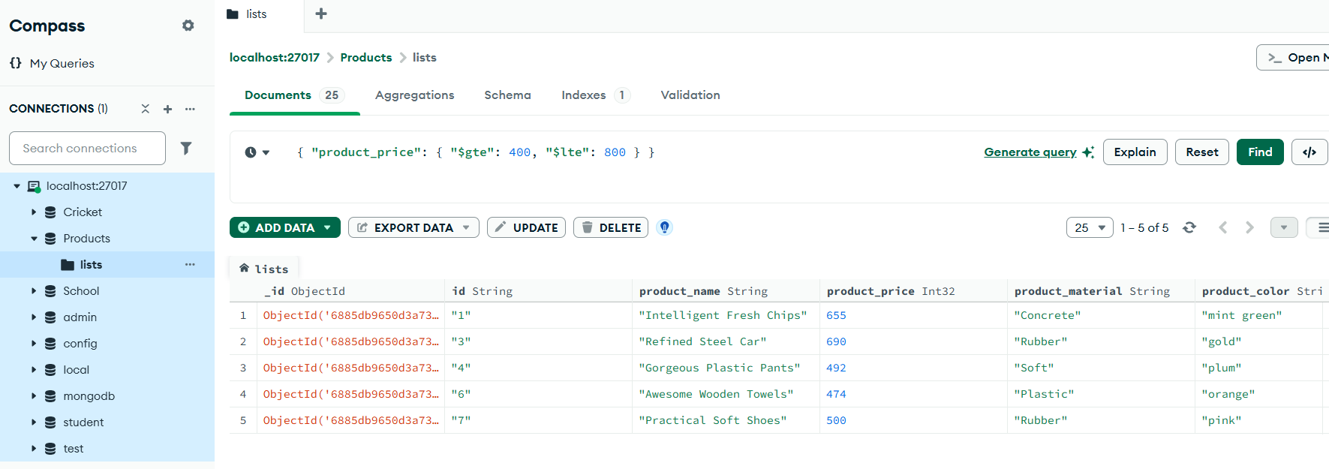

1. **Find the product price which are not between 400 to 600**

**{ "product_price": { "$not": { "$gte": 400, "$lte": 600 } } }**

* It shows the products where  product_price is less than 400 OR greater than 600.

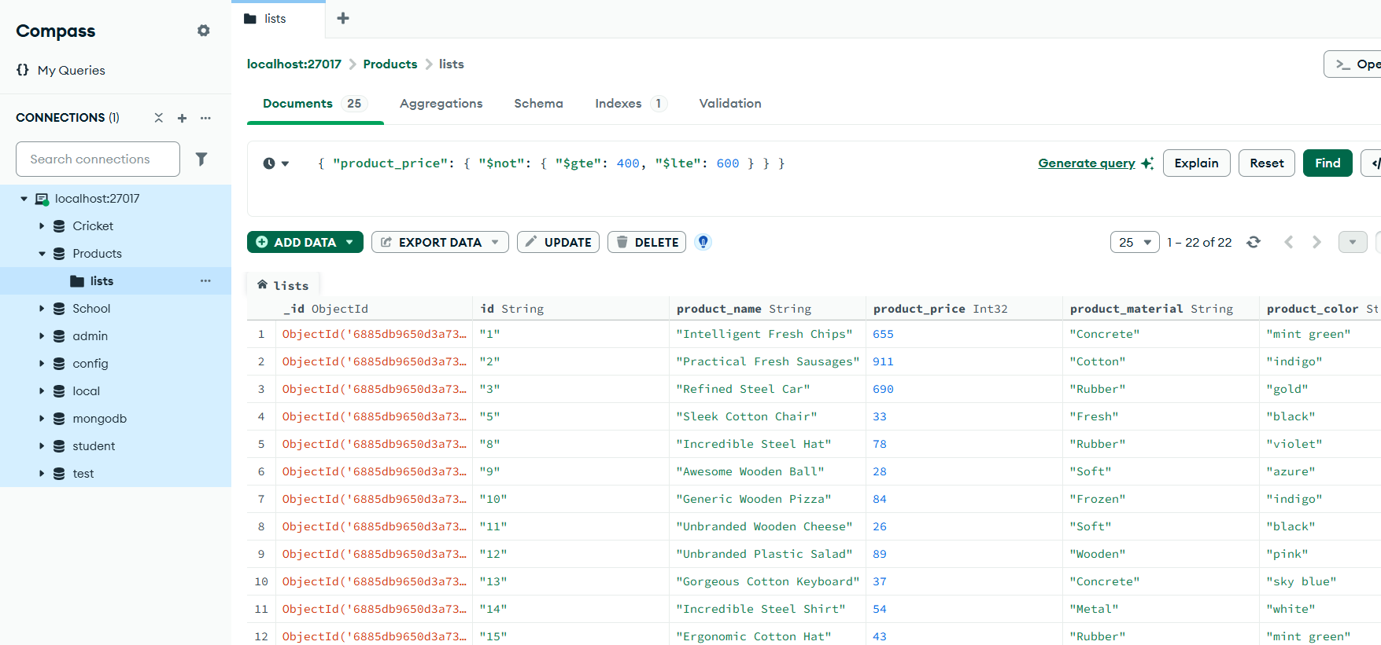

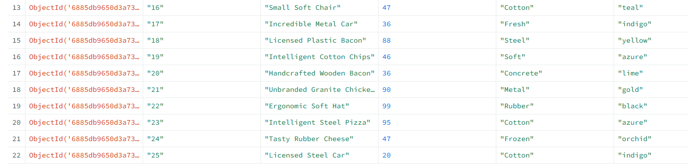

1. **List the four product which are greater than 500 in price**

**{ "product_price": { "$gt": 500 } }**

* It will show the products which are greater than 500 in price

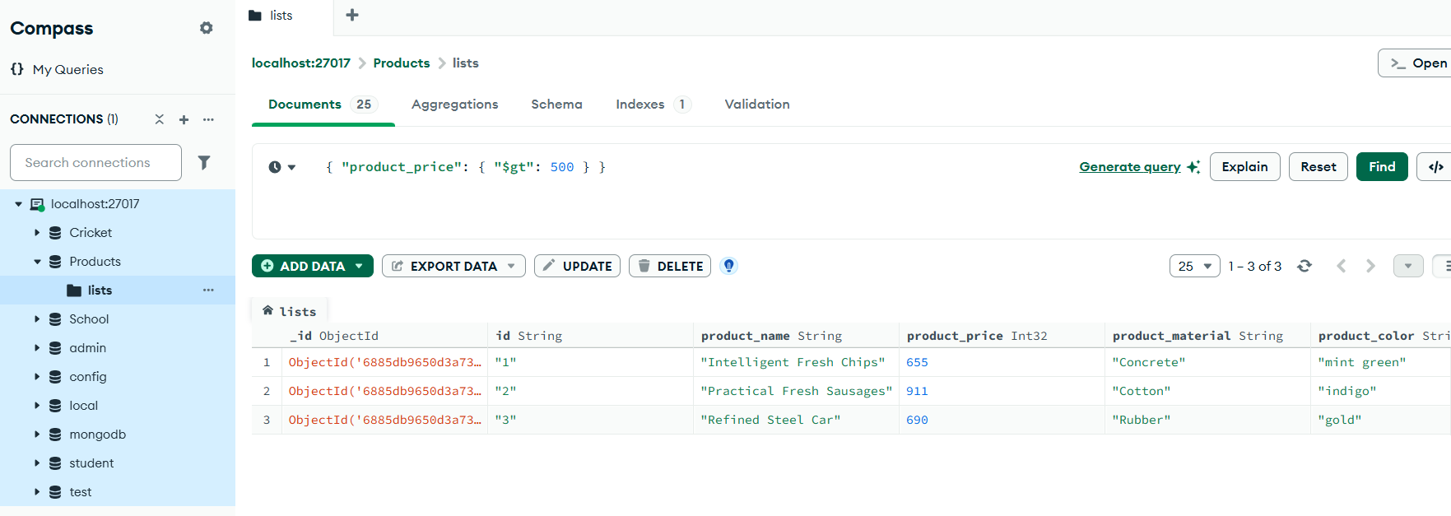

1. **Find the product name and product material of each products**

* In Project field type this query,
* **{ "product_name": 1, "product_material": 1, "_id": 0 }**
* It shows only product name and material.

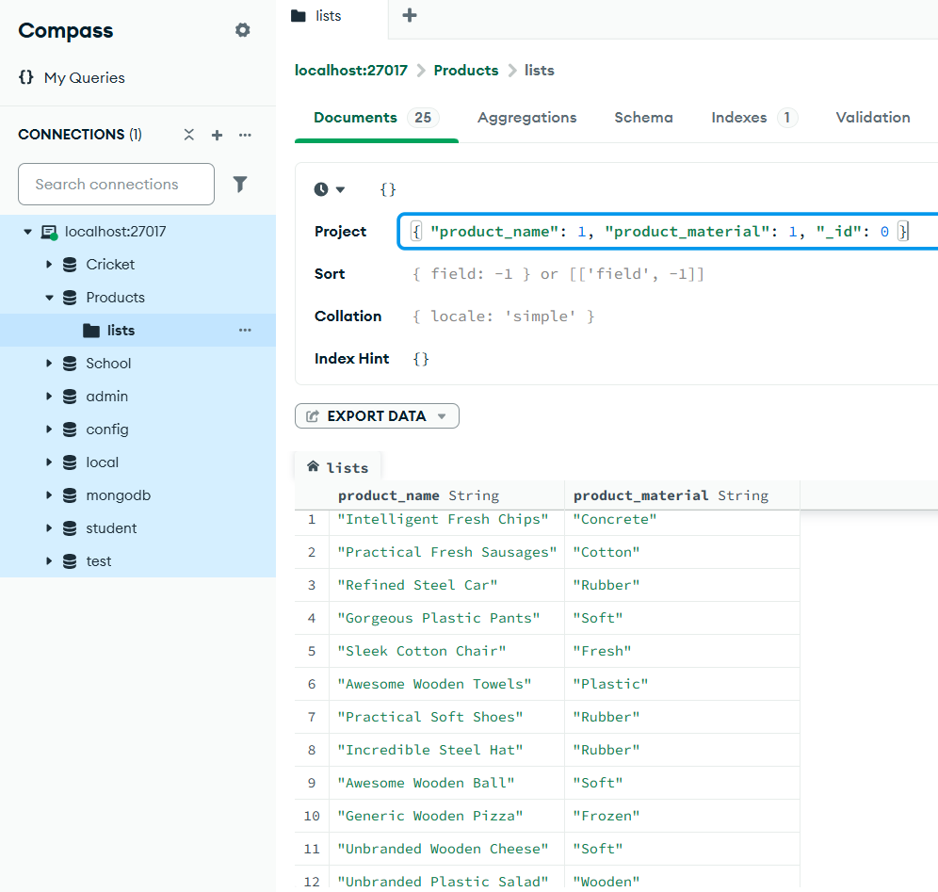

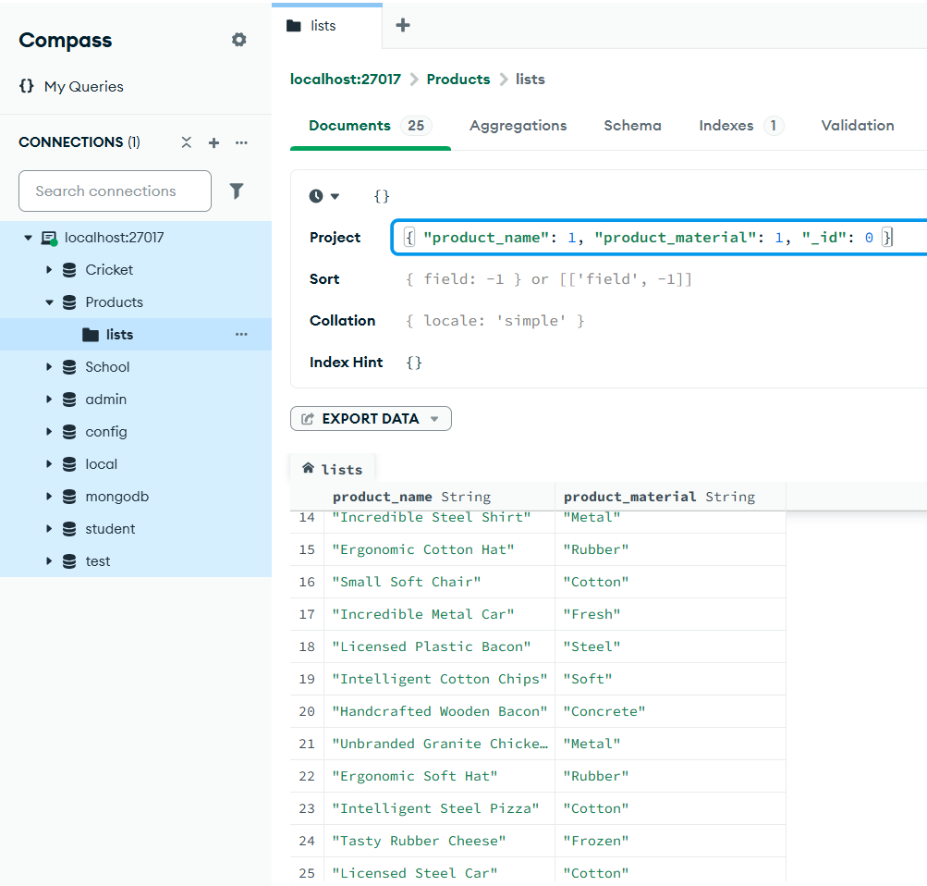

1. **Find the product with a row id of 10**

**{ "id": "10" }**

* It shows the specified product based on its Id

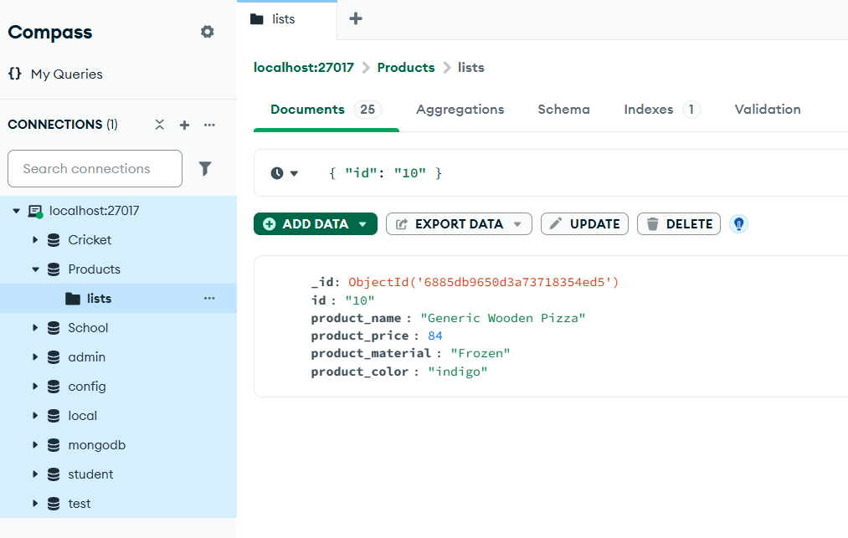

1. **Find all products which contain the value of soft in product material**

**{ "product_material": "Soft" }**

* It shows all products which contain the value "Soft" in product material

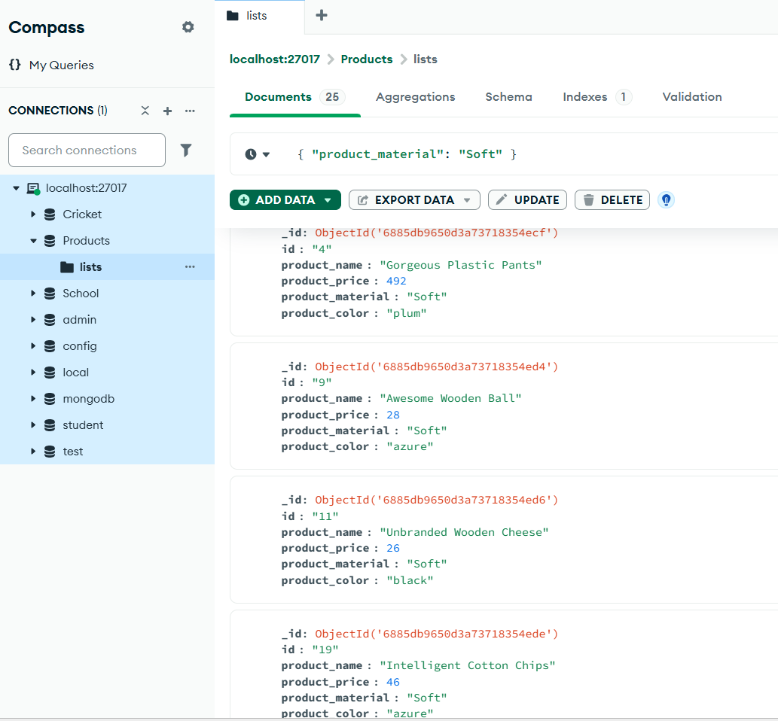

1. **Find products which contain product colour indigo and product price 911.00**

**{ "product_color": "indigo", "product_price": 911.00 }**

* It shows the products which contain product colour indigo and product price 911.00

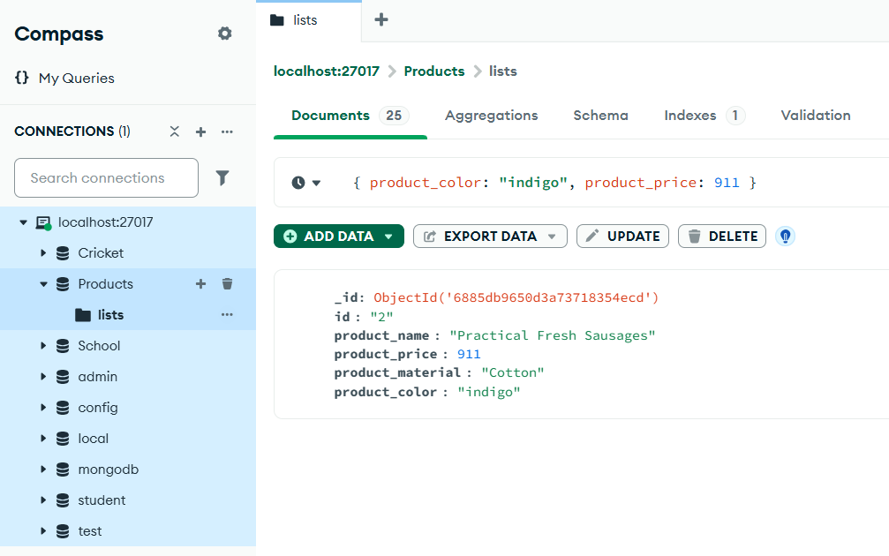

1. **Delete the products which product price value are same.**

**[**

**{ "$group": { "id": "$product_price", "count": { "$sum": 1 }, "ids": { "$push": "$_id" } } },**

**{ "$match": { "count": { "$gt": 1 } } }**

**]**

* Used aggregation to find duplicates, then delete them by _id

